**Phase 3 :- SQL**

3.1)Insert records from 42_District_wise_crimes_committed_against_women_2001_2012.csv into a table.

Ans:-

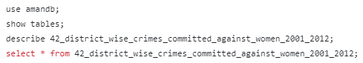

3.2)Write SQL query to find the highest number of rapes & Kidnappings that happened in which state, District, and year.

Ans:-



3.3)Write SQL query to find All the lowest number of rapes & Kidnappings that happened in which state, District, and year.

Ans:-

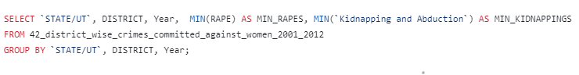

3.4)Insert records from 02_District_wise_crimes_committed_against_ST_2001_ 2012.csv into a new table

Ans:-

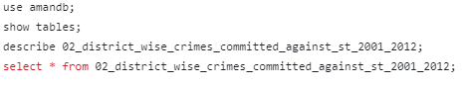

3.5)Write SQL query to find the highest number of dacoity/robbery in which district.

Ans:-

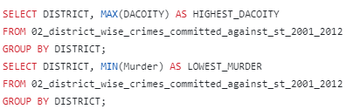

3.6)Write SQL query to find in which districts(All) the lowest number of murders happened.

Ans:-  
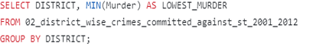

3.7)Write SQL query to find the number of murders in ascending order in district and year wise.

Ans:-  
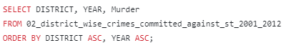

3.8.1)Insert records of STATE/UT, DISTRICT, YEAR, MURDER, ATTEMPT TO MURDER, and RAPE columns only from 01_District_wise_crimes_committed_IPC_2001 _2012.csv into a new table.

Ans:-

